**Marion County School District**

**Virtual Academy**

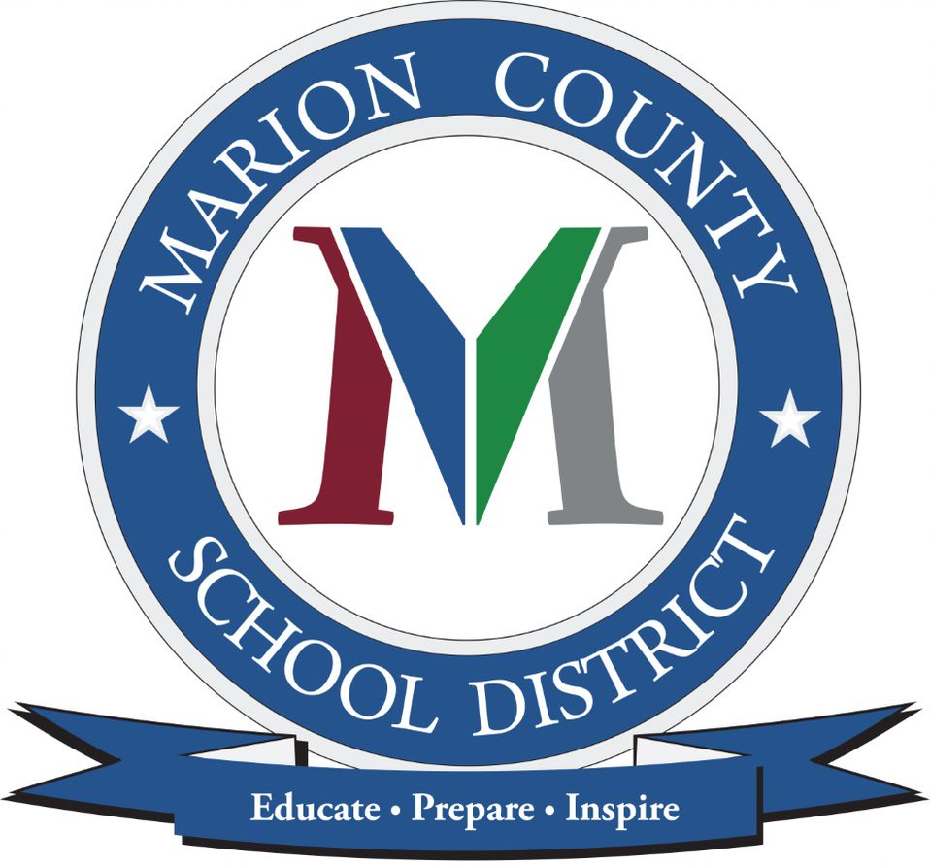

**Parent & Student Handbook**

**2020-2021**

**Welcome**

Welcome to Marion County Virtual Academy and the 2020-2021 school year!   This opportunity allows you daily flexibility as you complete your academic courses.  To be successful, you will need to be self-motivated, dedicated, and organized.  This new endeavor is exciting and we welcome your feedback.  If you have questions or need assistance, please contact me, Adrian Johnson at [ajohnson@marion.k12.sc.us](mailto:ajohnson@marion.k12.sc.us) or at 843-464-3740.  Open communication and time for completing your courses are the keys to your success in this learning environment.  Let’s make it an amazing year for virtual learning in Marion County School District.

**Purpose Statement:**  The mission of Marion County School District Virtual Academy is to provide motivated students a quality academic experience with the flexibility to complete their coursework in a virtual setting.  In alignment with Marion County School District’s purpose, our purpose is to educate, prepare and inspire our students to become college and career ready so they may be productive citizens in a changing global society.

We are here to help you in whatever ways we can.  When you have problems, questions, or concerns, please do not hesitate to share those with the Marion County Virtual Academy staff.

This handbook is provided so that you and your family have all the information you will need concerning school activities, rules, policies, and procedures.  This will help ensure that you have the most successful school year possible.

Again, I wish each of you the best for this school year, and please do not hesitate to let me know if there are any ways that I can help you with your educational experience here at Marion County Virtual Academy.

Sincerely,

Adrian Johnson

Marion County Virtual Academy Principal

**Mission Statement**

Marion County School District Virtual Academy (MCSDVA) is commited to providing students a high quality educational experience in a safe environment that will prepare students for the rigor of career and college success.

**Vision Statement**

MCSDVA will prepare and motivate our students no matter what it takes.

**How Does a Virtual School Work?**

Students will work on their own device or a device provided by the school district from home or another location with Internet access in order to complete their assigned courses. While the Virtual Academy aims to provide a daily flexible learning environment, the Academy operates on the assumption that students are logging in to their coursework every day, Monday-Friday.  Students will be provided a daily schedule with virtual classes beginning at 8 am and ending at 3 pm.

Your teachers will speak with you primarily through emails, messages within the Microsoft TEAMs platform, virtual conferencing tools, or by phone call if necessary.  When needed, teachers are available for support.  You will have a pacing guide/chart/assignment calendar that will be available in your course. This will give you a schedule from which to work.

Periodically throughout the year, attendance on site will be required for testing.  Those dates will be communicated with parents and students.

**Guiding Principles**

1. Marion County Virtual Academy will support our students and their families on an individual level by providing regular and clear feedback.
2. Marion County Virtual Academy will strive for flexibility and compassion when dealing with the unique circumstances of each of our students and their families.
3. The staff of Marion County Virtual Academy will commit to an environment of professional learning that emphasizes communication and collaboration to best meet the needs of our students

**Enrollment**

Students and parents must complete an application for the Virtual Academy.  Students are expected to remain in good standing academically, behaviorally, and in the area of attendance per MCSD Policy JE. Students should commit to the full school year. Any student not meeting any one of these requirements will require a parent conference with administration to discuss a plan of action.

**Academic Performance**

At the Virtual Academy, student success is a top priority.  However, virtual school is not a good fit for everyone.  Parent conferences will be held for students who are not demonstrating success in their course work may be required to work individually with teachers and/or counselors to ensure that the student is in the best possible place to succeed.

**Schedules**

**K-8**

A full-time enrollment in the Virtual Academy exists when a student takes the core curriculum.  The core curriculum for any grade includes math, English/Language Arts, science, and social studies.

**9-12**

In order to receive a high school diploma in the state of South Carolina, students must complete a total of 24 credits.  Marion County School District high schools operate on a semester schedule.  Therefore, students traditionally take 4 courses each semester, allowing them the opportunity to earn up to 32 credits.  Course selection follows the South Carolina Standard Course of Study and must meet requirements for graduation.

**Academic Integrity**

The students and faculty of Marion County Virtual Academy value honor, integrity, and responsibility and foster an atmosphere of cooperation and mutual respect.  Upholding these values will build a sense of community and allow student to achieve their greatest potential in character and citizenship.

**Student expectations**:

* Check email and LMS daily
* Submit a completed Acceptable Use Policy (AUP) to your teachers
* Make sure you know how to log into and use your email, Teams and LMS
* Create a learning space with no distractions
* Follow recommended schedule when at home
* Daily attendance will be monitored
* Follow MCSD dress code during virtual sessions when in-person (uniforms are not required for Virtual Academy students)
* Be on time for all in-person and virtual sessions
* Participate and engage with teacher and fellow classmates
* Cooperate with and follow all instructions from your teachers
* Be mindful of due dates, pace yourself and submit assignments on time
* Maintain academic integrity -do your own work
* If you are using a MCSD device, follow all rules for using and maintaining the equipment including internet behavior
* Refrain from taking pictures or recordings during virtual sessions-any slide shows or information you need will be provided on Teams or LMS
* Behave in a respectful, appropriate, safe and kind manner
* Links, recordings, or pictures from virtual sessions are not to be forwarded to anyone or shared on social media
* Keep your passwords safe to avoid being “hacked”
* Contact your teachers via email, through Teams or LMS when you need assistance
* Follow the Marion County School District Code of Conduct

**Parent expectations:**

* Allow for 24 hours M-F and 48 hours on the weekend for teachers to respond to your emails / requests
* Help your child(ren) create a learning space free of distractions
* Help your child(ren) with setting a routine for completing assignments
* Be familiar with your child’s daily online schedule
* Complete an Acceptable Use Policy permission form for your child(ren)
* Make sure your contact information is up-to-date to allow for teachers to contact you regarding your child(ren)’s progress
* Monitor your child(ren)’s progress
* Help your child(ren) be responsible and do their own work to maintain academic integrity
* Be familiar with Teams and LMS
* Help your child(ren) reach out to teachers when they need assistance
* Contact the school if your child(ren) is/are going to be absent
* Be familiar with student expectations and support your child(ren) with following them
* Monitor your child(ren) when they are online to help keep them safe
* Make sure your child(ren) have time in their schedule for physical activity, brain breaks and social opportunities
* Reach out to your child(ren)’s teachers when you have questions or concerns
* Daily attendance will be monitored

**Grading**

**Grading Scale**

In accordance with Marion County School District’s policy, the grading scale is as follows:

**A**= 90-100

**B**= 80-89

**C**=70-79

**D**=60-69

**F**= 59 or below

For students using the Edgenuity platform, students and parents may see different grades.  “Overall Grades” refer to the grades of work that has been completed.  However, “Actual Grades” take pacing into account.  Teachers will use Actual Grades.

Parents and students will be able to access grades at any time through the Power School Parent Portal.  Your student ́s teacher(s) will monitor work weekly and initiate communication if there are concerns about progress in one or more course.

**Grading Periods**

In accordance with Marion County School District’s grading practices, all students enrolled in the Virtual Academy will follow a 9 week grading period.  The dates for distribution of report cards are November 17, February 3, April 14, and June 14. (These dates are subject to change)

**Late Work**

At Marion County Virtual Academy, we pride ourselves on the daily flexibility we offer our students.  However, it is vital to the academic success of our students that they remain on pace with the standard course of study and the rest of their peers.  Students continually missing final due dates will be placed on an action plan and could potentially be removed from the Virtual Academy. Opportunities to go back and make up late work may be granted at the teacher’s discretion if the student shows acceptable progress in subsequent modules / units.

**Reteach/Retest**

In alignment with Marion County Schools’ grading guidelines, students in the Virtual Academy are allowed to retest major assessments.  Teachers may require students to attend tutoring or complete a review assignment in the course before allowing a retest.  In the event that a student’s retest grade is lower than the first test grade, teachers will take the higher of the two.

On the rare occasion a student is completing a course in Edgenuity, students may be given two opportunities to take a quiz.  It is up to the teacher’s discretion whether or not to allow any additional attempts.  Students are encouraged to limit the practice of taking 2 attempts on each quiz.  Students should also ensure that they take time between quiz attempts to review course material.

**Student Attendance/Absences**

Virtual attendance refers to the delivery of instructional content that does not occur in a physical classroom on school grounds or school property. This includes instruction provided via an online or electronic platform, as well as instruction provided in a physical offsite location separate from school property. Virtual attendance is determined by whether or not a student submits work or participates in assigned activities in accordance with the classroom teacher’s written requirements.

Students receiving virtual instruction who submit assignments or participate in assigned learning experiences by the deadline established by the classroom teacher should be considered present. Students who fail to submit assignments or participate in the assigned learning experience(s) by the deadline established by the classroom teacher will be considered absent. Whether the absence is “excused” or “unexcused” should be established by district procedures and policies and be consistent with state law and regulations. Students who are sick due to COVID-19 will be considered lawfully absent. If the illness is prolonged, such students will be eligible for medical homebound.

The school administrator will communicate any reduction in expected hours for any given week (based on Marion County School District workdays, holidays, and student release days) to students and parents via email/all call communication.

Documentation of Absences

Absences default to unexcused.  However, if you have documentation for an absence that meets the reasons approved by the State Department of Education for excused absences, email the information to the Virtual Principal.  These reasons are listed here:

* Illness or Injury
* Quarantine
* Death in the Immediate Family
* Medical or Dental appointments
* Court or Administrative Proceedings
* Religious Observance
* Educational Opportunity (prior approval by Virtual Academy staff is encouraged)
* Local School Board Policy
* Absence Related to Deployment Activity

**Make-Up Work**

The pace of completing work is very individualized for students enrolled in the Virtual Academy.  Students should work with the instructor to make a plan for making up any work missed due to absence.

**Virtual Homeroom**

Below is the schedule for weekly virtual homerooms, by grade level.  The purpose of homeroom is multifaceted.  This will be a time to help build community among students in the same grade; receive important MCVA information; and connect with a teacher at the Virtual Academy.

**Required Dates Onsite**

The following dates are those on which students at MCVA are expected to come onsite.  Please note that final exam schedules are still TBD.  These dates are the window in which exams will occur.

High School Dates

* End of Course Assessments (EOC) & SC Final Exams
  + **January**  - First Semester Exams
  + **May** - Second Semester Exams
* PSAT - *Tenth Grade Only*
  + **October , 2020**
* PreACT - *Tenth Grade Only*
  + **Nov.**
* ACT - *Eleventh Grade Only*

Middle School Dates

* State Assessments – SCPASS/SCREADY
  + **May**

Elementary School Dates

* State Assessments – SCREADY/SCPASS
  + **May**

**Diagnostic Testing**

Students in grades 2-10 will be expected to take the Measures of Academic Progress (MAP) assessment three times a year (beginning, middle, and end of the year) in both reading and math.  Each assessment will take anywhere from 45 - 75 minutes depending on the student.

* Beginning of the year window: **August 17 – October 30**
* Middle of the year window: **January 6 – January 22**
* End of the year window: **March 15 – April 1**

Marion County Virtual Academy will be administering the Fountas & Pinnell Benchmark assessment to all kindergarten – fifth grade students. This assessment is not used for grading purposes.  Instead, it provide teachers with valuable information and excellent data to help drive instruction for our students.  This assessment is given three times a year.

MCVA does strive to keep testing and assessments to a minimum.  We may receive several exemptions from some state and local assessments.  The ones we administer are either mandated for all public school students and/or of instructional benefit to the students and teachers.

**Communication**

In addition to students maintaining a regular schedule of completing schoolwork, it is important for students, school staff, and parents/guardians to maintain regularly scheduled communication.  The instructional staff will make regular contact with students and parents primarily through the email system within the student information system and/or via telephone when needed.  Both parents and students must make every effort to maintain consistent contact with the instructional staff.

**Behavior Guidelines**

There may be times when you are visiting a Marion County School’s facility or participating in face-to-face activities.  When you are on a Marion County Schools’ site, you are expected to follow the Marion County Schools code of conduct and dress code.

**Student Demographic Information**

It is extremely important that Marion County Virtual Academy be made aware of any changes to your demographic information.  We must have reliable contact information in case of an emergency.  Please inform school staff immediately with any changes to phone numbers, addresses, emails, and/or emergency contact information.

**Inclement Weather**

Marion County Schools will be closed when the Superintendent considers the weather conditions unfit for the safe operation of school buses.  School closings or delays will normally be announced by 6:00 AM on the local TV channels, on most local radio stations, on the district’s webpage, and the district’s Facebook page.  In most cases, Marion County Schools will also notify families at home with an automated phone call.  While the online learning platform will always remain open and accessible to students, the school calendar will accurately reflect when MCSD is closed.

**7th Grade Immunization Requirement**

In accordance with DHEC regulations, all incoming seventh grade students are required to receive the TDAP vaccine before school begins in August. In addition, the Hepatitis A vaccine has been added as a requirement for all students starting kindergarten in August 2020. Please reach out to the nurse at your base school if you have questions regarding immunization requirements.

**Student Health Information**

If you have any changes in your health status, or if you have any medical conditions or situations that the school should be aware of, please report them to the Marion County Virtual Academy administrator immediately.

**Withdrawal Procedures**

 Due to teacher allotments and master scheduling, if you or your student enrolls in Marion County Virtual Academy, the expectation is that you are committed to the Virtual Academy for at least one year.  However, if there is a need to withdraw from school, a parent or guardian needs to come to the office to complete the necessary paperwork.  You will need to return any books, technology, and any other items that belong to the district.  Upon completion of these requirements, your withdrawal process will be finalized.  Please note that the curriculum in the virtual school courses may be paced differently than other school opportunities.  You will no longer be enrolled in the digital platform offered by Marion County Virtual Academy if you withdraw.

**Arrival and Departure of Students and Families**

Marion County Virtual Academy is located at the Palmetto Education Center, 200 Broad Street, Mullins South Carolina 29574. We request that you make an appointment if you would like a meeting with a Virtual Academy staff person.

During any face-to-face events, parents must sign in/out each student.  When students are visiting other campuses for activities, parents and students need to follow the procedures of the school they are visiting.

**Extracurricular Opportunities Eligibility**

Marion County Virtual Academy students will be eligible to participate on Marion County School athletic teams and extracurricular Opportunities at their base school during after school hours. Students interested in programs such as band or other arts should contact the Marion County Virtual Academy principal who will work with the school to make accommodations.  MCVA has no control over these schedules.  Students who participate will be held to the same daily attendance requirements as the students at the school.  Parents must ensure their child will be dropped off and picked up on time each day.

**Computer/Technology Accessibility**

Students enrolled in the program will be provided a device if needed for the duration of the school year. Upon enrollment, students should secure reliable Internet.  If you do not have this technology available, contact the Marion County Virtual Academy principal.

**Proctored Exams**

Beyond the state required exams, proctored exams can be requested by teachers at any time and for any reason in an effort to ensure academic integrity.  It is the student and parent’s responsibility to work collaboratively with school staff to take the exam in a proctored setting as needed.

**Exceptional Children Services/Accommodations**

Support from AIG, ESL, Intervention, 504 plans, etc. will be provided by the student’s base school. Supports for students with IEPs will be provided by the base school and determined by IEP goals and availability in a virtual environment. Our teachers will work with students and parents to ensure success.  Please contact the Marion County Virtual Academy principal with questions related to Individualized Education Plans or Section 504 Accommodation Plans.

**Curriculum Providers**

Students enrolled in our Virtual Academy will adhere to South Carolina academic standards. K-5 students will be taught by Marion County School District teachers. Students in grades 6-12 will have a teacher from Marion County School District teachers as well as utilize learning platforms such as VirtualSC and Edgenuity.

**Computer Usage and Internet Policy**

**Introduction**

It is the policy of Marion County School District Virtual Academy to: (a) prevent user access over its computer network to, or transmission of, inappropriate material via Internet, electronic mail, or other forms of direct electronic communications; (b) prevent unauthorized access and other unlawful online activities; (c) prevent unauthorized online disclosure, use, or dissemination of personal identification information of minors; and (d) comply with the Children’s Internet Protection Act.

**Access to Inappropriate Material**

To the extent practical, parents should consider using technology protection measures (or “Internet filters”) to block or filter Internet, or other forms of electronic communications, and access to inappropriate information.

Specifically, as required by the Children’s Internet Protection Act, blocking shall be applied to visual depictions of material deemed obscene or child pornography, or to any material deemed harmful to minors.

Technology protection measures may be disabled for adults or, in the case of minors, minimized only for bona fide research or other lawful purposes.

**Education, Supervision, and Monitoring**

It shall be the responsibility of all members of the MCSDVA staff and learning coaches or parents/legal guardians to educate, supervise and monitor appropriate usage of the online computer network and access to the Internet in accordance with this policy, the Children’s Internet Protection Act, the Neighborhood Children’s Internet Protection Act, and the Protecting Children in the 21st Century Act.

Procedures for the disabling or otherwise modifying any technology protection measures shall be the responsibility of the parent, legal guardian, or designated representative, such as learning coach.

**Computer Use Policy**

Access to the Internet via computer equipment and resource networks provided to qualifying students because of enrollment in MCSDVA are intended to serve and pursue educational goals and purposes. Communications and Internet access should be conducted in a responsible and professional manner reflecting the school’s commitment to honest, ethical, and non-discriminatory practice. Therefore, the following is prohibited:

* Any computer use that violates federal, state, or local law or regulation including copyright infringement and other unlawful behavior
* Knowing or reckless interference with the normal operation of computers, peripherals, or networks
* The use of MCSDVA Internet-related systems to access, transmit, store, display, or request inappropriate materials
* Any use that is deemed to adversely affect MCSDVA

**Computer Requirement and Distribution Policy**

Each MCSDVA family is required to have a computer that meets the minimum specifications necessary to access the Virtual Academy. Families must acquire and maintain Internet access throughout the year in order to participate in the school.

A computer system will be loaned upon approved enrollment of the new student(s) in MCSDVA. K-5 families would receive a laptop computer, while every middle and high school student would receive an individual laptop. Multiple computers loaned to a single-family in grades K-8 would be subject to review. This loan is based on the financial need of the family and/or those approved students whose family qualifies for the federal free-or-reduced meals program and who need a computer system. This determination will take place during the enrollment process. Families may elect to waive the loan of a computer system. Sometimes situations change, and a need may arise later. If that happens, please contact your child’s homeroom teacher to determine eligibility for a computer loan.

If using a personal computer, please verify that it meets the minimum requirements for successfully launching K12 systems and curriculums.

**Student Internet Safety**

Do not reveal on the Internet personal information about yourself or other persons. For example, you should not reveal your name, home address, telephone number, or display photographs of yourself or others to persons outside of MCSDVA.

Do not agree to meet in person anyone you have met only on the Internet and who is not affiliated with MCSDVA.

**Network Etiquette**

At MCSDVA, parents and students are expected to follow the rules of network etiquette, or “netiquette.” The word netiquette refers to common-sense guidelines for conversing with others online.

Please abide by these standards:

* Avoid sarcasm, jargon, and slang. Swear words are unacceptable.
* Never use derogatory comments, including those regarding race, age, gender, sexual orientation, religion, ability, political persuasion, body type, physical or mental health, or access issues.
* Focus your responses on the questions or issues being discussed, not on the individuals involved.
* Be constructive with your criticism, not hurtful.
* Review your messages before sending them. Remove easily misinterpreted language and proofread for typos.
* Respect other people’s privacy. Do not broadcast online discussions, and never reveal other people’s email addresses.

**Accountability**

Posting anonymous messages is not permitted unless authorized by the course’s online teacher. Impersonating another person is also strictly prohibited.

* Students must use only their own user names and passwords and must not share these with anyone.
* Students may not interfere with other user’s ability to access MCSDVA or disclose anyone’s password to others or allow them to use another user’s account. Students are responsible for all activity that is associated with their usernames and passwords.
* Students should change their passwords frequently, at least once per semester or course is encouraged.
* Students must not publicly post any messages that were sent to them privately.
* Students must not download, transmit or post material that is intended for personal gain or profit, non-MCSDVA commercial activities, non-MCSDVA product advertising, or political lobbying on an MCSDVA owned instructional computing resource.
* Students may not use MCSDVA instructional computing resources to sell or purchase any illegal items or substances.
* Students are not allowed to upload or post any software on MCSDVA instructional computing resources that are not specifically required and approved for student assignments.
* Students may not post any MP3 files, compressed video, or other non -instructional files to any MCSDVA server.

**Prohibited Conduct**

The following is a list of behaviors not permitted by the MCSDVA:

* Disregard or disrespect for directions of teachers, school staff, or administrators
* Disruption and/or interference with the normal and orderly conduct of the school and school-sponsored activities
* Use of profanity, vulgar language or obscene materials
* Engaging in insults, verbal abuses such as name-calling, ethnic or racial slurs or using derogatory statements to other students, school personnel or other individuals
* Bullying behaviors that are intended to harass, intimidate, ridicule, humiliate or instill fear in another individual
* Insults or attacks of any kind against another person
* Harassment (posting unwelcome messages to another person) or use of threats
* Posting material that is obscene or defamatory or which is intended to annoy, harass or intimidate another person. This includes distributing “spam” mail, chain email, viruses, or other intentionally destructive content.